**LIGHT REPLACING STICK**

**A report submitted in partial fulfillment of the Academic requirements for the award of the degree of**

**Bachelor of Technology**

B.VIJAY (18H51A0536)

BHAVANISATHI(18H51A0585)

D.BHARANI(18H51A0594)

A.ARAVIND(18H51A05C4)

P.SUSHMA(18H51A05D9)

S.AKHILESH(18H51A05E3)

**UNDER THE COURSE**

**SOCIAL INNOVATION IN PRACTICE**



**CENTRE FOR ENGINEERING EDUCATION RESEARCH**

**CMR COLLEGE OF ENGINEERING & TECHNOLOGY**

**(Autonomous)**

**(NAAC Accredited with ‘A+’ Grade & NBA Accredited)**

**(Approved by AICTE, Permanently Affiliated to JNTU Hyderabad)**

**KANDLAKOYA, MEDCHAL ROAD, HYDERABAD-501401**

**2023-24**

**CENTRE FOR ENGINEERING EDUCATION RESEARCH**

**CMR COLLEGE OF ENGINEERING & TECHNOLOGY**

**(Autonomous)**

**(NAAC Accredited with ‘A+’ Grade & NBA Accredited)**

**(Approved by AICTE, Permanently Affiliated to JNTU Hyderabad)**

**KANDLAKOYA, MEDCHAL ROAD, HYDERABAD-501401**



**CERTIFICATE**

This is to certify that the report entitled **“LIGHT REPLACING STICK”** is a bonafide work done by **B.Vijay(18H51A0536), BhavaniSathi (18H51A0585), D.Bharani (18H51A0594), A.Aravind(18H51A05C4),P.Sushma(18H51A05D9),S.Akhilesh(18H51A05E3)** of II B.Tech, in partial fulfillment of the requirements for the award of the degree of Bachelor of Technology, submitted to Centre for Engineering Education Research, CMR College of Engineering & Technology, Hyderabad during the Academic Year 2023-24.

**( Names of the project coordinators) (Mr. B.Suresh Ram)**

1. Mr. B. Suresh Ram HOD-CEER

2. Ms. Ch.Neelima

3. Mr. K. Raju

**DECLARATION**

We, the students of I B.Tech of Centre for Engineering Education Research , CMR COLLEGE OF ENGINEERING & TECHNOLOGY, Kandlakoya, Hyderabad, hereby declare, that under the supervision of our course coordinators, we have independently carried out the project titled **“Light Replacing Stick”** and submitted the report in partial fulfillment of the requirement for the award of Bachelor of Technology in by the Jawaharlal Nehru Technological University, Hyderabad (JNTUH) during the academic year 2023-2024.

**STUDENT** **NAME ROLL NUMBER SIGNATURE**

B.VIJAY (18H51A0536)

BHAVANISATHI (18H51A0585)

D.BHARANI (18H51A0594)

A.ARAVIND (18H51A05C4)

P.SUSHMA (18H51A05D9)

S.AKHILESH (18H51A05E3)

**ACKNOWLEDGEMENT**

We are obliged and grateful to thank Mr.B.Suresh Ram, Head(CEER), CMRCET, for his cooperation in all respects during the course.

We would like to thank the Principal of CMRCET, Dr.V.A.Narayana, for his support in the course of this project work.

Finally, we thank all our faculty members and Lab Assistants for their valid support.

We own all our success to our beloved parents, whose vision, love and inspiration has made us reach out for these glories.

**ABSTRACT**

India is lacking in many things which are highly secured than other things. As it is a fast-growing country among the world so that everyone is very busy with their own work. Everyone agrees that replacing a light is one of the simplest things to do. The danger of getting shocked is not only dying by electricity, but also in some cases when one has to climb up somewhere insecure to change the bulb, they can fall and get hurt. We can overcome this situation by using light replacing stick. It will allow only some members who are assigned in it. It is a time-consuming process and it reduces the manpower. It also saves us from getting shocks.

As we all know that elder people generally suffer from pains that they can’t climb ladders or stools . So, our project light replacing stick can be used by elder people easily without using any extra tools like ladder etc.,

Our project is mainly focused on how to change and fix any kind of bulb and tube lights securely. It can be used in homes, in most of the companies and mainly in electrical department.

|  |  |  |  |
| --- | --- | --- | --- |
| **CHAPTERS** | | **DESCRIPTION** | **PAGE No** |
|  |  | Abstract |  |
| 1 |  | Introduction | 1 |
| 2 |  | Literature Review  Literature Review | 2 |
| 3 |  | Problem Definition |  |
|  | 3.1 | Community interaction with  the concerned project team | 11 |
|  | 3.2 | Problem Statement | 12 |
|  | 3.3 | Objective | 12 |
|  | 3.4 | Requirement Analysis | 13 |
| 4 |  | Methodology |  |
|  | 4.1 | Conceptual Design | 19 |
|  | 4.2 | Block Diagram | 23 |
|  | 4.3 | Design Description | 26 |
| 5 |  | Implementation |  |
|  | 5.1 | Results and Discussions | 28 |
|  | 5.2 | Conclusions | 28 |
| 6 | 6.1 | Appendix | 29 |
|  | 6.2 | References | 29 |
|  | 6.3 | Source Code | 30 |
| 7 |  | Team Details | 32 |

**TABLE OF CONTENTS**

**CHAPTER-1**

**INTRODUCTION**

**“Not only do the shards require cleanup,**

**but the bulb's base may wind up stuck inside a socket.”**

Changing a light or bulb is a delicate process, one that can be complicated by a variety of issues. A lot of light bulbs are hot, for example, and they can singe your hands just as easily as they can set a towel on fire. Owning a bulb or light changer eliminates those risks by

placing you at a remove from the light bulb, and by enlisting a flame-retardant clamp that can't be set ablaze.

Shattering glass is a headache in any environment where a lot of hard-to-reach light bulbs need to be replaced. Not only do the shards require cleanup, but the bulb's base may wind up stuck inside a socket. There are select cases where a person may need to use a potato or some other non-conductor to ferret out the remaining parts. In a public setting, any broken glass can represent a liability. A broken bulb may also constitute an electrical hazard,

Our light replacing stick is tool which helps in changing the defect lights and bulbs in a easy way. Usually everyone thinks that replacing a light is an easy task. But at times, we may face many problems like we may get shock because we directly change the lights or bulbs without ensuring whether the switch is in off or on position while fixing the light.

**CHAPTER-2**

**LITERATURE REVIEW**

**2.1. Existing Solutions:**

**1.Manual Work:**

We normally fix the light or bulb manually using manpower. Sometimes, we change bulb immediately without ensuring whether the bulb is hot or not. Then we may get hurt like our hands may burn. So, to avoid such problems we need a tool that changes the bulb.

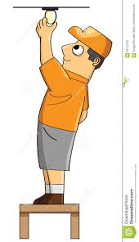

FIG.1:FIXING BULB

Of course there is always the possibility of the screw part (or base) getting stuck in the fixture. This would happen mostly to the bulbs used outside the house or in more humid rooms where the humidity can rust the screw base and make it stick inside the fixture.

Now there are two things that can happen: the bulb breaks off the base, or the more dangerous one is that it doesn’t come off easily and due to too much pressure, it breaks in one’s hand causing injury. The bulb is a very thin glass and will break easily. So if you must put excessive pressure on a bulb, then use a thick glove to protect your hand.



FIG2:PROBLEM WE FACE

**DISADVANTAGES:**

* Skidding off while fixing the bulb or light.
* Had to buy extra tools like ladders.
* Elders cannot change the bulb or light.

**2. Unger FS00 Flood Sucker:**

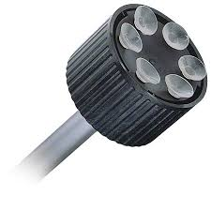

FIG3:UNGER FS00 FLOOD SUCKER

Unger FS00 Flood sucker is one of the existing solutions for our problem. It consists of 5-6 suckers in a circular manner. For attaching the bulb we need to apply more force and also after fixing bulb to the holder we need to apply force for detaching from bulb holder which may lead to breakage of bulb. This is the main disadvantage.

This is of fixed height and shape. So, we can’t use this for all kinds of bulbs and ceiling height. Safely and easily change hard-to-reach floodlights. Six-point suction cup holder securely attaches to flat-faced bulbs. Threaded insert mates with all Unger telescoping poles.

The Unger FS00 Flood Sucker employs multiple small suction cups rather than just a large one, increasing your chances of gripping a floodlight securely. Unfortunately, it can be used only with poles that have tension clips, not universal threads.

Unger FS00 Features:

* 1.Easily change floodlights and other flat lightbulbs safely from the ground
* 2.Features suction cups that attach to bulb
* 3.Fully insulated
* 4.Snaps onto telescopic poles for changing bulbs in high-access areas
* 5.For changing flat light bulbs in high access areas without ladders. With suction cups.
* 6.Enables safer and faster bulb change from the ground.

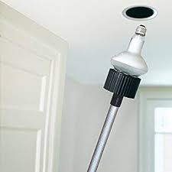

FIG4: FIXING BULB USING UNGER FLOOD SUCKER

**DISADVANTAGES:**

* We need to apply more force when we fix the bulb.
* If more force is applied to the bulb while detaching , the it may lead to bulb breakage.

**3.Alden Ease Out:**

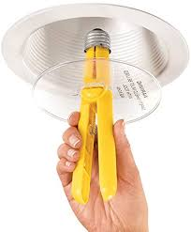

FIG5: ALDEN EASE OUT

Replacing broken light bulbs used to be dangerous and difficult. Now with the Alden B Ease-Out series you can quickly and safely remove broken lamps while eliminating frustration and reducing risk of electrical shock.

The Alden Ease-Out 2-piece kit comes with everything you need to remove damaged standard bulb bases. The extractor comes with a safety shield to help prevent broken glass from falling into the eyes and face. Perfect for the handyman's toolkit, the tool is re-usable for multiple removals. Simple mechanical design to safely and easily remove broken standard base bulbs.

Ease-Out broken bulb remover is constructed with an insulator material and safety shield to safely and easily remove both standard base and candelabra bulbs.

FEATURES:

* Fast, safe, easy removal of broken light bulbs.
* Avoids electric shock, cut fingers and mangled light fixtures.
* Save time, frustration and risk.
* Safety shield helps prevent broken glass from falling into eyes and face.
* Re-usable for multiple extractions**.**

**DISADVANTAGES:**

* The main disadvantage of this is we cannot fix the bulb.
* We can just remove the bulbs that are broken.
* It can’t be extendable.
* It is hard to handle the tool at larger heights.
* We need extra tools.
* It is not suitable for elder people.

**4. Wagic Giraffe:**

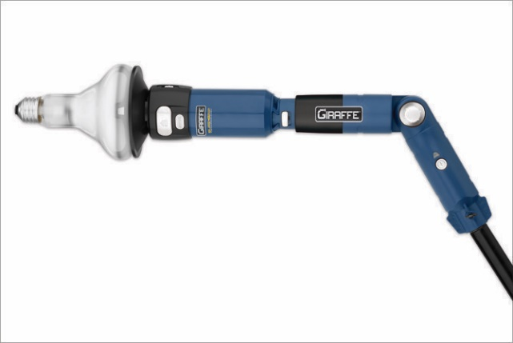

FIG6:WAGIC GIRAFFE

The WAGIC 21316 Giraffe Sure Grip Light Bulb Changing System is a handy item to have around the home. It is very simple to operate. The Giraffe light bulb changing system is built with a patented vacuum system. This light bulb changer features and tilts to a 90-degree angle for ease of use. The unit is also compatible with candelabra varieties as well.

Using vacuum technology to create a firm grip, the Wagic Giraffe is about as nontraditional as they come. Rather than twisting it manually to unscrew an existing light or install a new one. Sure-Grip Vacuum Technology creates a gentle suction to hold most smooth light bulbs; two suction cups are included for different size bulbs.

FEATURES:

* Giraffe light bulb changing system is easy to use
* Vacuum holds the bulb into place
* Has a 90-degree angle for most bulbs
* Works well with candelabra bulbs for added convenience.

**DISADVANTAGES:**

* We need to apply more force when we fix the bulb.
* Setting the device up is tricky and maneuvering it into place can be awkward so a degree of mechanical aptitude is necessary for success.
* The plastic knob for the rotator arm should be made bigger & rubberised for better grip.
* Sometimes it gets difficult to unscrew it.
* Also, an optional sling would be great for support in case you lose grip of stick.
* This works best when the stick is used straight up rather than at an angle.
* Another design suggestion is to provide some kind of a net or a catch bucket in case the bulb loses suction & falls off.

**GAPS IN EXISTING SOLUTIONS:**

All the existing solutions have many disadvantages. Thefollowing are the gaps we found in those existing solutions:

* Skidding off while fixing the bulb or light.
* Had to buy extra tools like ladders.
* Elders cannot change the bulb or light.
* We need to apply more force when we fix the bulb.
* If more force is applied to the bulb while detaching , the it may lead to bulb breakage.
* The main disadvantage of this is we cannot fix the bulb.
* We can just remove the bulbs that are broken.
* It can’t be extendable.
* It is hard to handle the tool at larger heights.
* It is not suitable for elder people.

**5. Proposed Solution:**

As we have gone with the need statement, we gone through a literature review so that we can know what exactly our prototype must contain, what kind of updates it should have. While going through this process we came across constraints like :

1.It should be shock proof.

2.The stick is less in weight.

3. It should be adjustable according to ceiling height.

4. Easily used by elders.

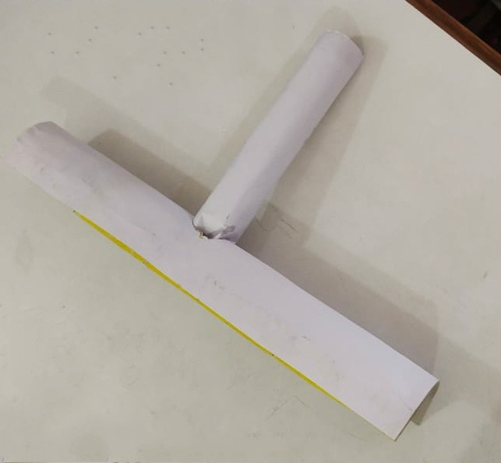

FIG7: TUBELIGHT CHANER PAPER MODEL

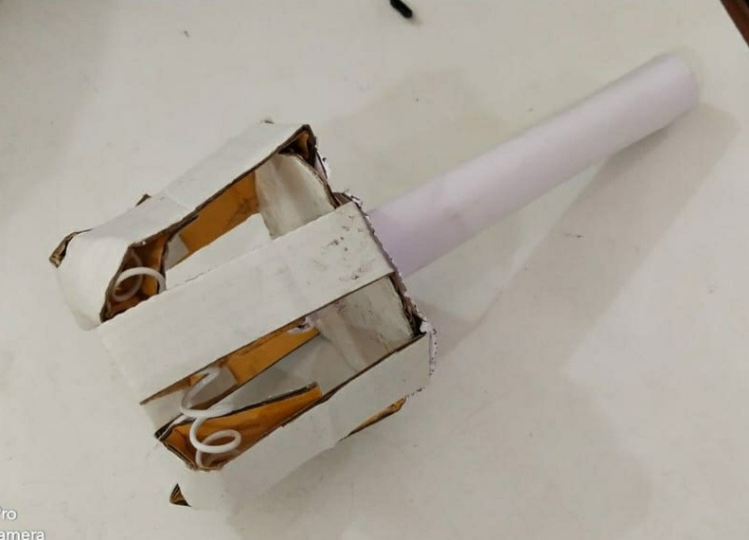

FIG8:BULB CHANGER PAPER MODEL

**CHAPTER-3**

**PROBLEM DEFINITION**

**3.1. Community interaction with the concerned project team:**

On behalf of community visit, we have visited a village near to our college. There we have identified many problems like sanitation problems, mosquitoes, security problems, no proper streetlights, problem faced by the people while fixing the lights etc., Out of all these problems we have decided and chose to make a light replacing stick.

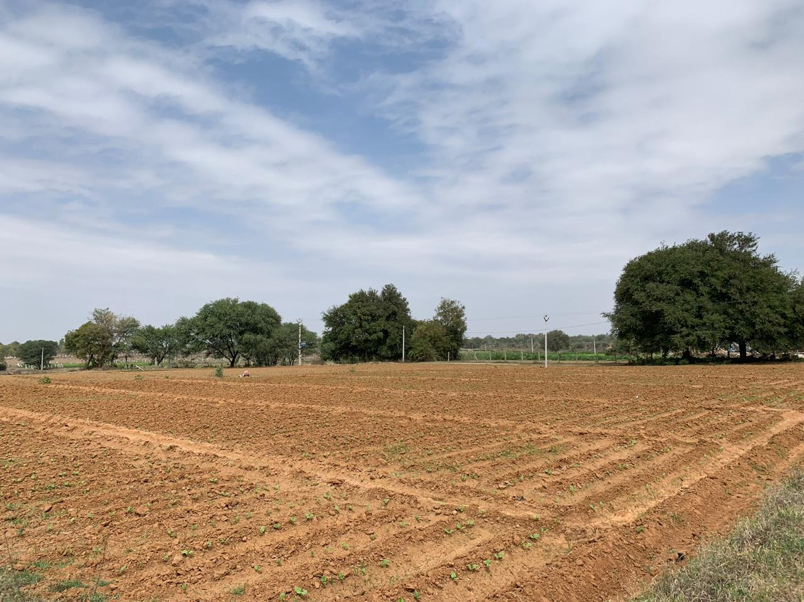

FIG 9: COMMUNITY VISIT

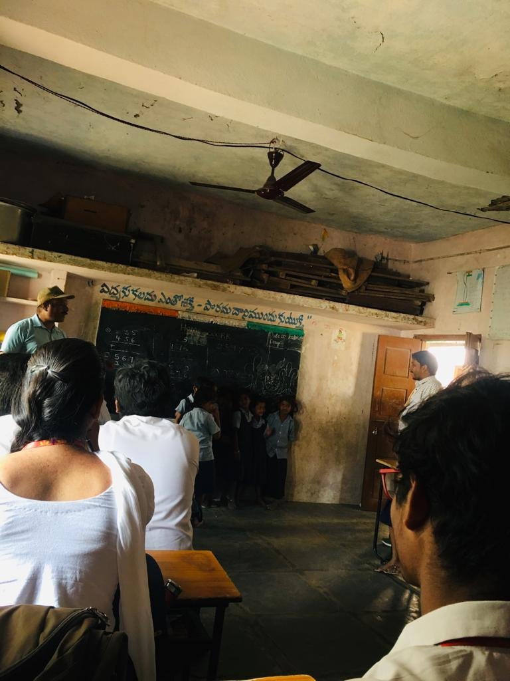

FIG10: COMMUNITY VISIT

**3.2 Problem Statement:**

Everyone agrees that replacing a light is one of the simplest things to do. The danger of getting shocked is not only dying by electricity, but also in some cases when one has to climb up somewhere insecure to change the bulb, they can fall and get hurt.

So, we have designed a project that is user friendly, that can be used without knowing it and works for longer time.

**3.3 Objective:**

1.The stick should be adjustable according to the light size.

2.The stick should be adjustable according to the ceiling height.

3. It should be easy to use.

4. The stick should be exchangeable for both light and bulb.

**3.4 Requirement Analysis:**

1. COIL SPRING:

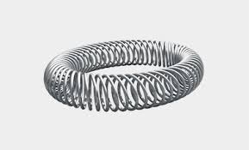

FIG11: COIL SPRING

A coil spring is a spring that is connected at each end to create a circular shape. They are flexible and are designed to withstand pressure from all directions. We are using this because it can adjust itself according to the bulb size and holds it properly. This spring helps the bulb to change

The material of the spring is thereby subjected to a bending moment, either reducing or increasing the helical radius. Metal coil springs are made by winding a wire around a shaped former a cylinder is used to form cylindrical coil springs.

There are many spring designs. In everyday use, the term often refers to coil springs.Out of all the springs we have in our life, we chose coil spring as it could be extendable according to the bulb’s diamerte

2. PVC PIPES:

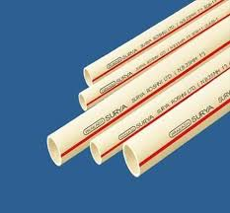

FIG12: PVC PIPES

Pipes are used making the stick. They are light in weight. Here we are using two sticks of different diameter such that one fixes into other. It is made such that it can be extended according to the height required. Hence, can be used as stick. Also, it is used in fixing the tube light with the stick and to make rubber tyre straight.

Pipe is made of many types of material including ceramic, glass, fiberglass, many metals, concrete and plastic. This depends on the process that the pipe will be used for the process.

Plastic Pipe fittings include PVC pipe fittings, PP / PPH pipe fitting mould, PE pipe and ABS pipe fitting. PVC comes in two basic forms: rigid (sometimes abbreviated as RPVC) and flexible. Pipes are used for support and extension i.e., to reach the desired height. Only, pipes are selected because they don’t conduct electricity and are light in weight.

3. RUBBER TUBE:

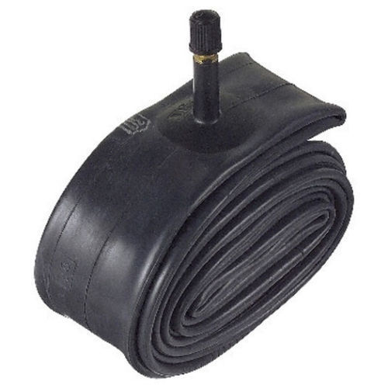

FIG13: RUBBER TUBE

Rubber exhibits unique physical and chemical properties. Rubber is a material which can stretch and shrink.

It is used to join the two pipes of different diameters so that we can move or adjust the stick accordingly. It is also placed inside the tube light replacer so that tube light doesn’t gets effected. The largest consumers of rubber are tires and tube.

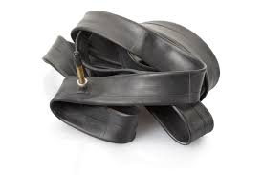

FIG14: EXPANDABLE TUBE

Rubber type of material is chosen because it is expandable. We have different kind of bulbs with different diameters. The spring is placed along a rubber rube material with plastic strips in a circular shape. This is also used to join the pipes that are used for extension.

4. CIRCULAR PLASTIC MATERIAL:

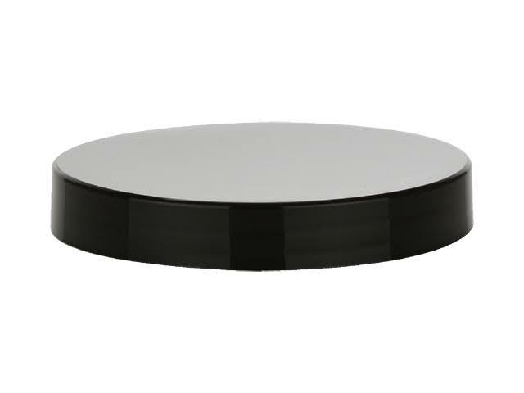

FIG15: CIRCULAR PLASTIC MATERIAL

All the plastic strips are fixed to a circular plastic material which is used as base. This base is connected to the pipes. Plastic is material consisting of any of a wide range of synthetic or semi-synthetic organic compounds that are malleable and so can be melded into solid objects. Due to their low cost, ease of manufacture, versatility, and imperviousness to water, plastics are used in a multitude of products of different scale.

The circular plastic material is chosen as it provides a perfect basement for the plastic strips that we use to make a cylindrical shape. The plastic is light in weight and does not conduct electricity. The circular plastic material which we have chosen provides two concentric circles. We push the plastic strips into the gap between these two concentric circles by the help of glue. Then the circular plastic material is fixed with a small piece of pipe. The pipe is then fixed to the long pipe.

5. RUBBER TYRE:



FIG16: RUBBER TYRE

Tires provide a footprint that is designed to match the weight of the vehicle with the bearing strength of the surface that it rolls over by providing a bearing pressure that will not deform the surface excessively. To hold the tube light we are using a rubber tyre. Since tyre is made of rubber it can be adjusted according to the tube light diameter.

Tyre is chosen because tyre can hold the lights perfectly, any other material can damage the light like light may break if the material is hard one for example metal. If metal is placed, then if more force is applied the bulb may break. Also, the metal is a pure conductor of electricity. So, it may conduct electricity. The stick also becomes heavy if metal is placed as a base.

Hence, to avoid such problems we have chosen a tyre. It is light in weight comparatively. It doesn’t conduct electricity. It doesn’t do any damage to the light. For more convenience a plastic material is placed in the tyre to make it straight. The plastic material is then covered by the rubber tube.

6. PLASTIC STRIPS:

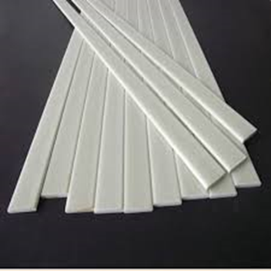

FIG17: PLASTIC STRIPS

We use plastic strips to hold the bulb as well as the spring. The strips are used to provide support for the bulb. So that bulb doesn’t fall. These strips are covered by a rubber tube so that it helps to hold the spring.

We have chosen plastic because it is a bad conductor of electricity.

The other materials like iron strips are heavy in weight and can conduct electricity. Wooden sticks of less thickness can also be placed but are not suitable for weather conditions. Also, they get damaged because of termites and hence cannot be used. Hence, we have chosen plastic strips.

**CHAPTER-4**

**METHODOLOGY**

Our problem is to design a light replacing stick which can be used to change a tube light and also can change a bulb. We designed a stick such that it can be replaced according to our convenience i.e., if we want to change a tube light, we use the stick and the light replacing device. Similarly, if we want to change bulb then we use the stick and bulb replacing device.

**4.1 CONCEPTUAL DESIGN:**

Our design includes very simple mechanism.The design of the prototype is as shown below in the figure

**FOR BULB REPLACING:**

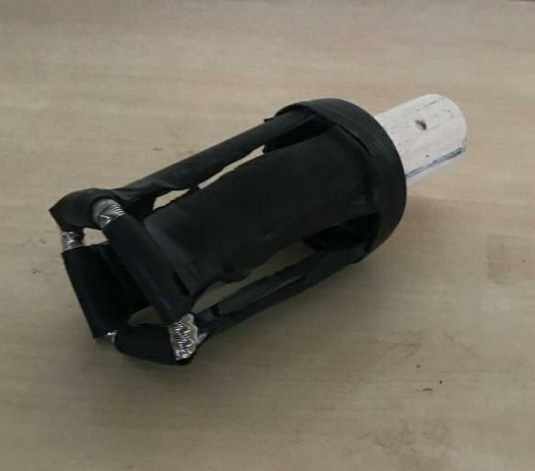

FIG18: BULB CHANGER

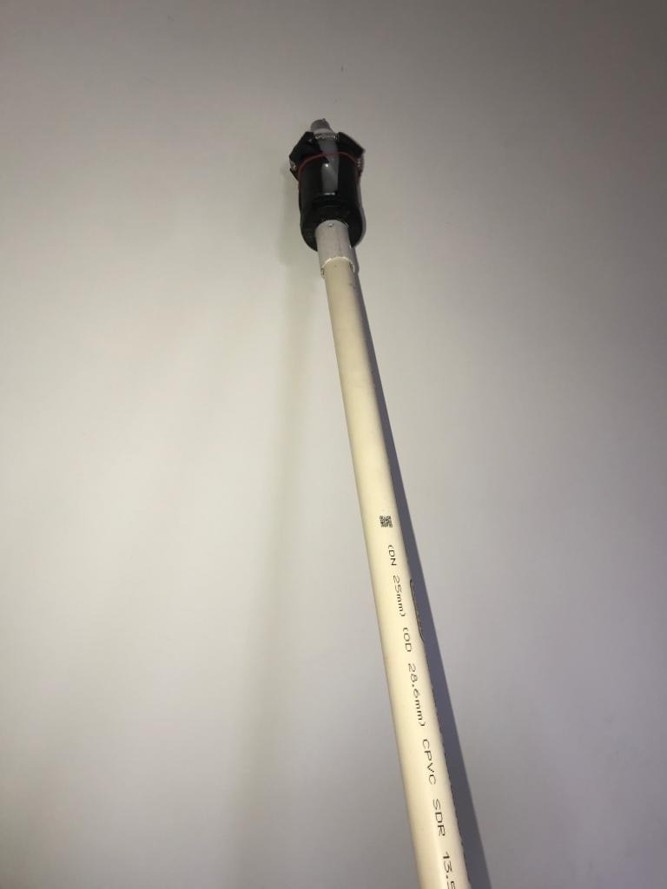 Here, we first used a circular base to place all the plastic strips. We arranged this plastic stirp in a cylindrical way. We covered these plastic strips with the rubber tube. The tube is covered in such a way that it can hold the spring as shown in the figure. The coil spring is fixed. This whole part is fixed to a small pipe. The pipe is now connected to the stick(pipe).

FIG19: BULB CHANGER WITH STICK

**FOR LIGHT REPLACING:**

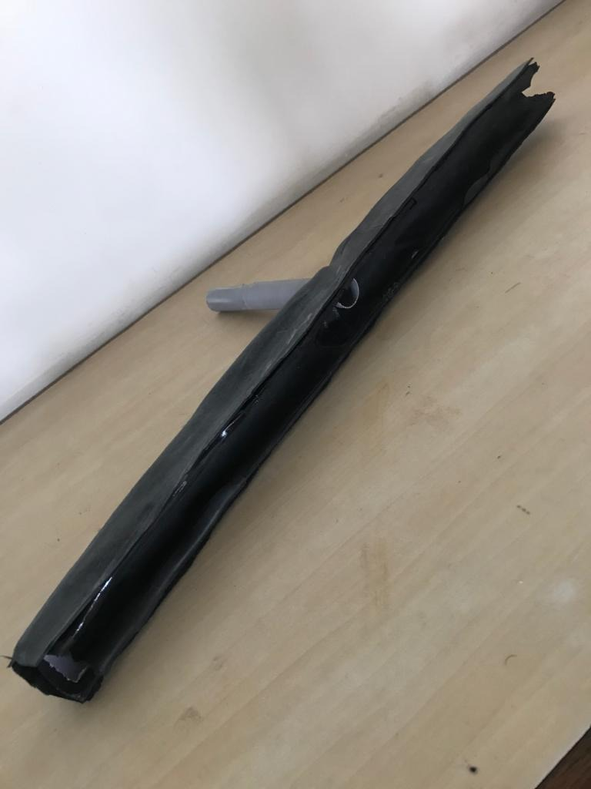

FIG20: TUBE LIGHT CHANGER

Here, we used a tyre. We know that a tyre cannot be straight as it is in circular shape. So, to make it straight we placed a plastic strip (a pipe of less thickness) and made the tyre straight. The inner side of the tyre is then covered by rubber type material. Before covering the tyre and the plastic material we made a hole such that we can join it with the stick.

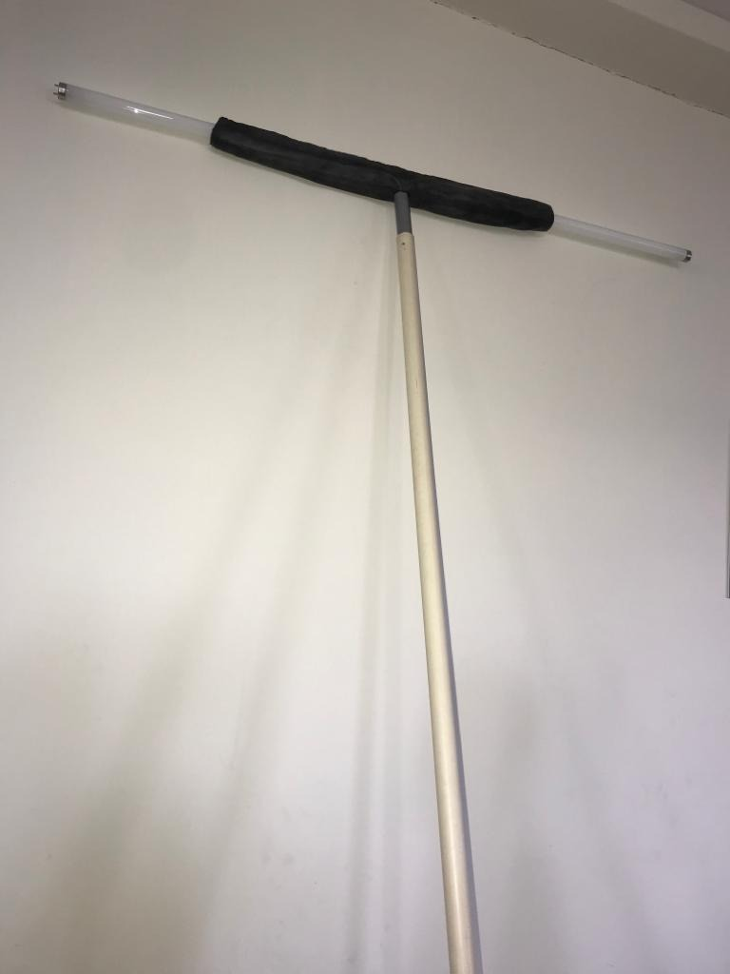

FIG21: TUBE LIGHT CHANGER WITH STICK

**4.2 BLOCK DIAGRAM:**

**FOR BULB REPLACING:**





FIG 22: DIAGRAM FOR BULB REPLACING WITH STICK

* First take the stick and fix the bulb fixer to it.
* Then according to your need whether you want to fix the bulb or remove it from holder you need to use it.

**FOR LIGHT REPLACING:**

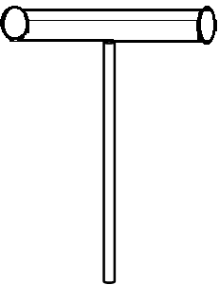





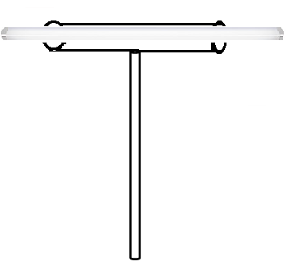

FIG 23: DIAGRAM FOR LIGHT REPLACING WITH STICK

**4.3 DESIGN DESCRIPTION:**

**FOR BULB FIXER:**

**TO REMOVE THE BULB:**

Whenever we find a problem with bulb, we need to change it. Using the above shown stick we can change the bulb easily. The above stick can be used in two ways. First, we need to remove defect bulb which is already fixed to the holder. So, this stick helps us in removing the bulb. The bulb fixer is attached to the stick. Now, we need to place the bulb fixer such that it can hold the bulb. Now rotate the stick in anti-clockwise. The defect bulb now gets removed and bulb fixer holds the defect bulb.

**TO FIX THE BULB:**

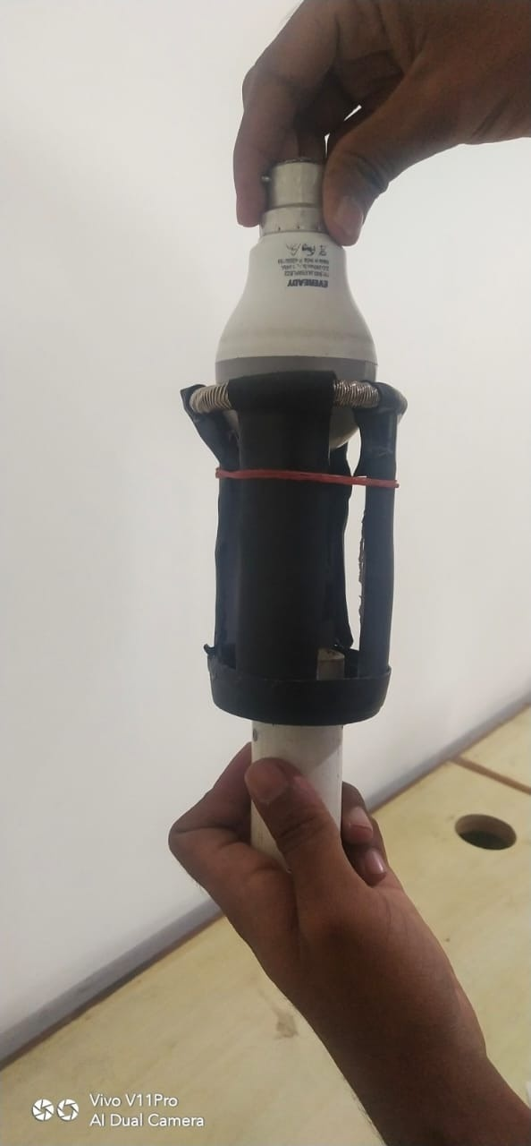

FIG22:INSERTING BULB INTO BULB CHANGER

To fix the new bulb into the holder take the new bulb and place it in the bulb fixer such that it looks straight and properly fixed with the spring. Ensure that it should not be fixed deep inside the bulb fixer. Now, take the stick with bulb fixer and place the bulb in the holder and rotate the stick in clock-wise direction. The bulb gets fixed into the bulb holder. Remove the bulb fixer slowly by applying less force in backward direction.

**FOR TUBE LIGHT:**

**TO REMOVE THE TUBE LIGHT:**

Whenever we find a problem with tube light, we need to change it. Using the above shown stick we can change the light easily. The above stick is used to change the tube light as well as remove the defect light. The light changer consists of a tyre in a semi-cylindrical shape. So, we can place the light in this tyre. This is attached to the stick so that it can reach the desired height. Now, to remove the defect tube light place the tube light into the light changer and rotate the stick in downward direction so that it gets loosen and gets removed.

**TO FIX THE TUBE LIGHT :**

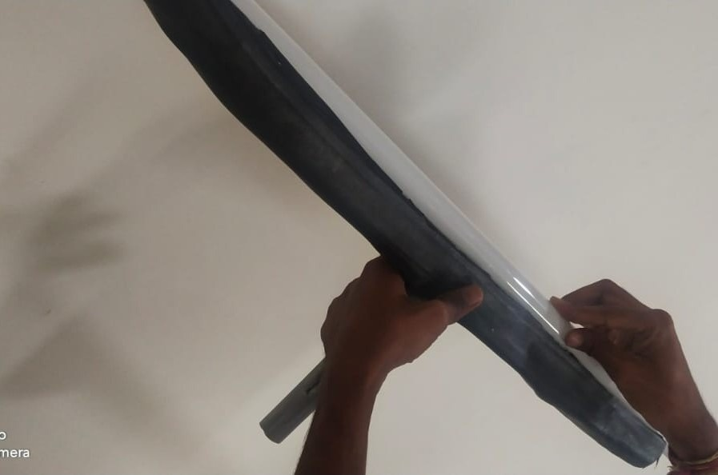

FIG22:INSERTING TUBE INTO TUBE LIGHT CHANGER

Now to fix a new light into the holder, place the new light into the light changer and then ensure that the two pins of the light are straight. Place these two pins of one side into the light holder and then adjust the pins of other side into the holder. Rotate the stick either in upward direction or downward direction. The light gets placed into the holder.

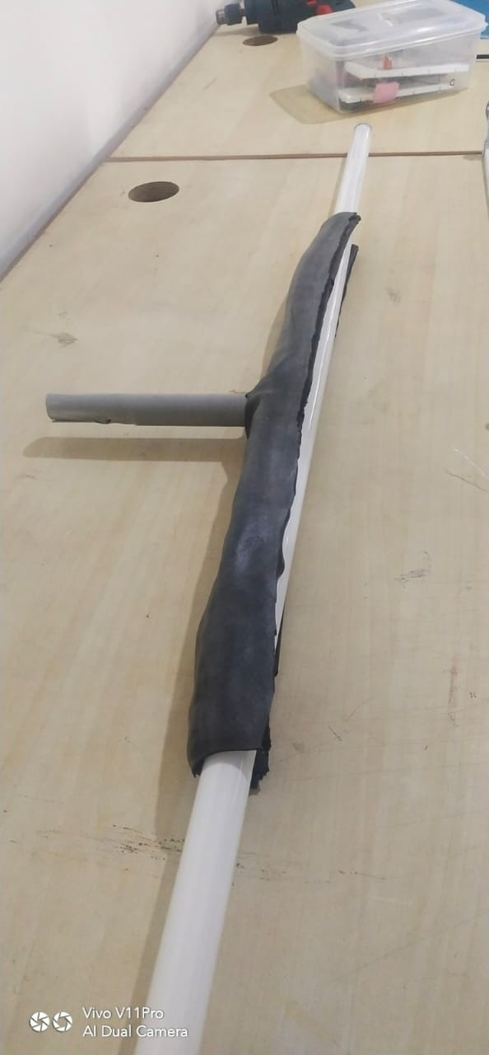

FIG 23: TUBE LIGHT CHANGER

**CHAPTER-5**

**IMPLEMENTATION**

**5.1 RESULTS AND DISSCUSSION:**

The light replacing stick can be used in the following areas:

1. Household

2. Showrooms

3. Malls

4. Hospitals

5. Educational Institutions

By using our light replacing stick, many of us can save time and the risks that we generally face during replacing the default lights. This will make our life easier and once bought will remain for life long.

**5.2 CONCLUSION:**

Here by we conclude that our light replacing stick is a tool that helps in changing any kind of bulbs or lights which are at any heights easily without using any extra tools like ladders, stools etc., The stick is less in weight and can be used by adults. It is also cost feasible. It is portable. It can be used in any kind of fields.

**6.1. APPENDIX:**

<https://images.app.goo.gl/mZUEQEtpYcYrAw8E7>

<https://www.google.com/imgres?imgurl=https%3A%2F%2Fpaintingtheme.com%2Fwp-content%2Fuploads%2F2016%2F08%2Fladder-falling-down-933x1024.jpg&imgrefurl=https%3A%2F%2Fpaintingtheme.com%2Fhow-to-use-any-kind-of-ladder-safely%2F&tbnid=_UKuU76rNv_aRM&vet=1&docid=n2pHaxJsZoCt7M&w=933&h=1024&source=sh%2Fx%2Fim>

**6.2. REFERENCES:**

<https://images.app.goo.gl/mZUEQEtpYcYrAw8E7>

<https://images.app.goo.gl/hhgZEkX3wyqcroUaA>

<https://www.walmart.com/ip/Alden-9207P-Grabit-Bulb-Ease-out-Standard-Light-Bulb-Extractor-2-Piece-Kit/839788378>

<https://www.supplychimp.com/go/unger-fs00-flood-sucker-bulb-changer1.html>

**CHAPTER-6**

**SOURCE CODE**

**TEAM DETAILS**

|  |  |  |
| --- | --- | --- |
| **PHOTO** | **NAME** | **ROLL NUMBER** |
|  | NEHA SAMREEN | 21H51A0421 |
|  | I.SHRAVANI | 21H51A0412 |
|  | K. PAVAN KUMAR | 21H51A0418 |
|  | S. HARSHITH SAI | 21H51A0445 |
|  | A. THIRUPATHI | 21H51A0453 |